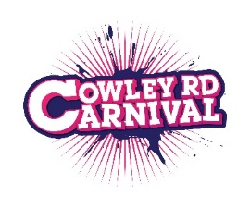

Carnival @ Home ’21

Street Party Checklist

Get Started Now!
Chat about the idea with neighbours you know
Plan 1 or 2 meetings and invite everyone in your street in writing
Consider if you need to close the road. You can choose an informal street meet
If you want to close the road.
Apply to Oxford City Council for a road closure license by 22 May.

Planning
The date is 4 July – what time do you want to hold the party? Consider your schedule of activities.
Share jobs out so that there is not one ‘organiser’
Be inclusive and involve everyone.
Plan food, games, etc. Activities for ages and tastes.
Music not too loud, late, or long, and for all tastes.
(Tune in to Virtual Carnival @ Home from noon – 6pm and DJ sets on Mixcloud)
Arrange road signs
Borrow, buy, or make bunting
You probably don’t need insurance – if in doubt check with the council.
As long as you aren’ t selling alcohol, you won’t need a licence to sell it!
Get the Neighbours’ Street Play Guide
Consider what equipment you need to make, bring, or hire eg: tables, chairs, prizes, banners

Week Before
Send out reminder for party and moving some cars
Display legal order for road closure if you are required to
Set up road closure barriers and bunting etc.
Clear up and open the road after party

On the Day

Afterwards
Share photographs with your friends and neighbours, and tell us all about it @cowleycarnival #cowleyroadcarnival

